A000-Afr-Niger-Bozo (Bo-so)-Sorko Culture-Male Semitic Head from Djenné-16th c

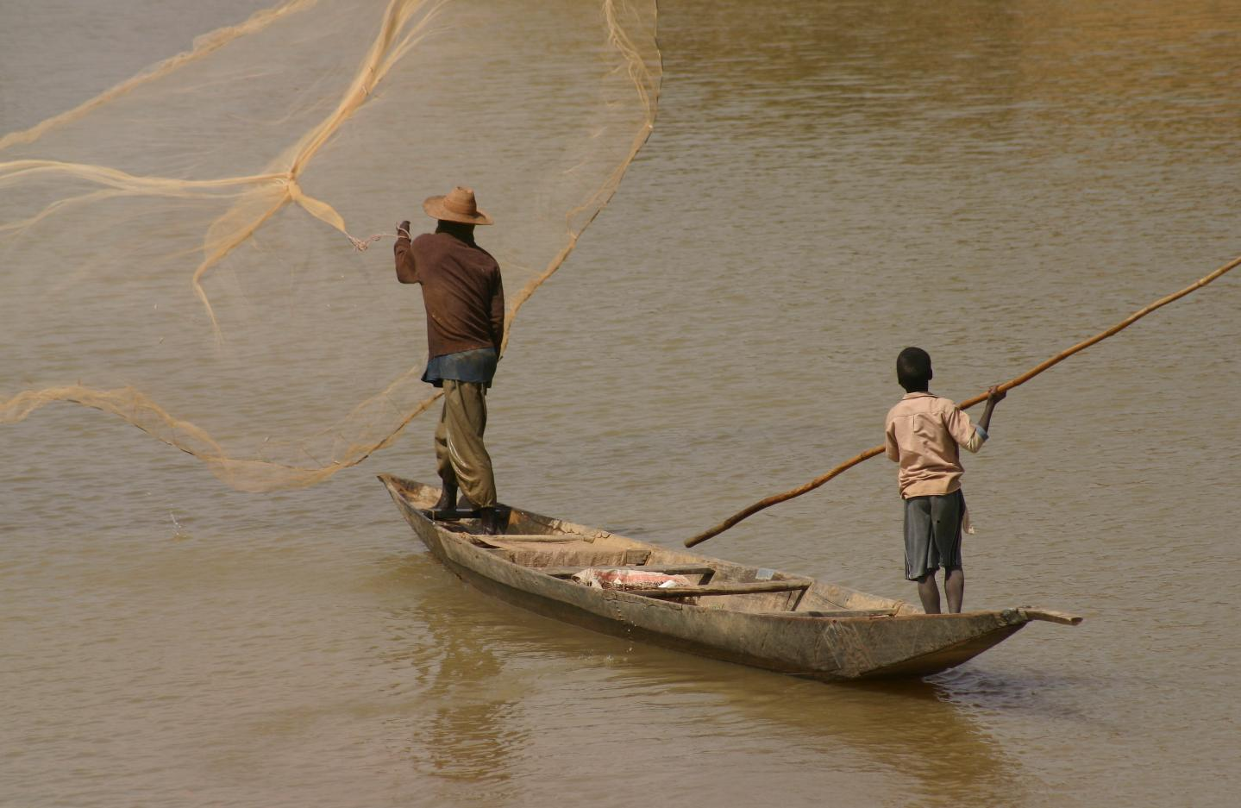

The **Bozo** West African ethnic group are considered "the masters of the river" and **are** the principal fishing people of the Inner Niger Delta in Mali. The name *Bozo* is thought to derive from the neighboring Bambara people's word "*bo-so*," meaning "bamboo" or "grass house" which has been accepted as referring to the whole of the ethnic group. However, local people refer to themselves by one of four dialects: Hainyaho (a few thousand speakers), Tièma cièwe (2,500 speakers in 1991), Tiéyaho (a few thousand speakers) and Sorko or Sorogama (200,000 speakers in 2005) all of which form a branch of northwestern Mande languages. 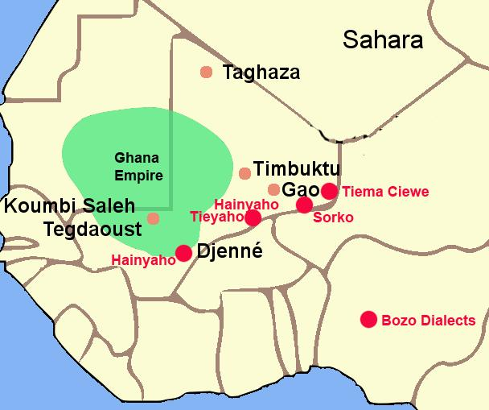

The Bozo are famous for their fishing and are occasionally referred to as the "masters of the river." They are also famous for their metal smithing and have developed their art to a high degree by using riverine themes such as the two bronze examples shown here, one of a mermaid that may have its inspiration from the first Europeans who entered their area in the early sixteenth century and the other of a dual wedding party being escorted along the Niger River in a crocodile-prow fishing pirogue.

The Bozo culture took shape under the Ghana Empire in what is now southeastern Mauritania and western Mali that was founded before 830 CE, when the Bozo took possession of the banks of the Niger. This event was of great importance since the domesticated camel continued to provide transport for an expanded trans-Saharan trade in gold, ivory, salt and natron which could then be sent in exchange for manufactured goods to Mediterranean ports connecting to Europe, to Egypt and to the Middle East.

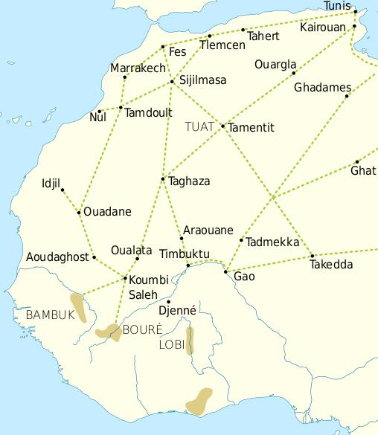

Trade routes of the Western Sahara c. 1000-1500. Goldfields are indicated by light brown shading.

This trade resulted in an increasing surplus that helped expand urban centers such as Gao, Timbuktu and Djenné. In this context the Bozo founded the cities of Djenné and Mopti, where they built magnificent mosques of mud brick. 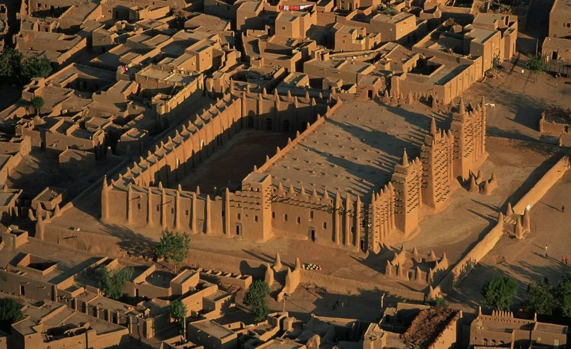

Djenné mosque.

The Bozo also used locally available clay to produce unusual terracotta clay busts of famous trans-Saharan Arab traders of which the present collection has two.

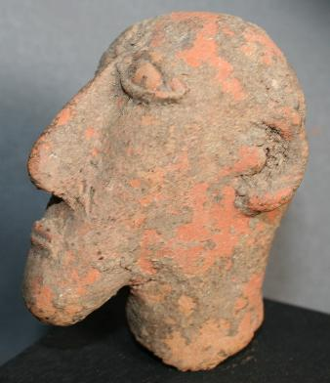 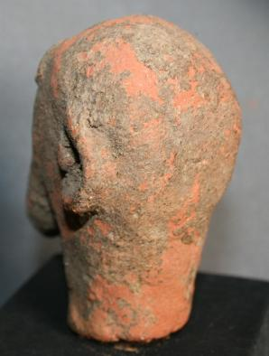

This very rare terracotta head of a male with Semitic features dates to the 14th-15th centuries when Arab traders were traveling caravan routes across the Sahara desert to the trading areas of west Africa along the Niger River. This terracotta was excavated in Djenné which houses an ancient Mosque that dates to the 14th century as well and this individual, who was of high rank, may have been one of the leaders who was responsible for the building of the Mosque.